**Lab: 5: Character and String Manipulation, Arrays, and Other Memory Operands**

**Objective:**

To explore string manipulation and memory operations in MIPS Assembly Language.

**Task 1:**

Create a program to prompt the user for an integer, read the input, and output the rightmost digit.

**Code:**

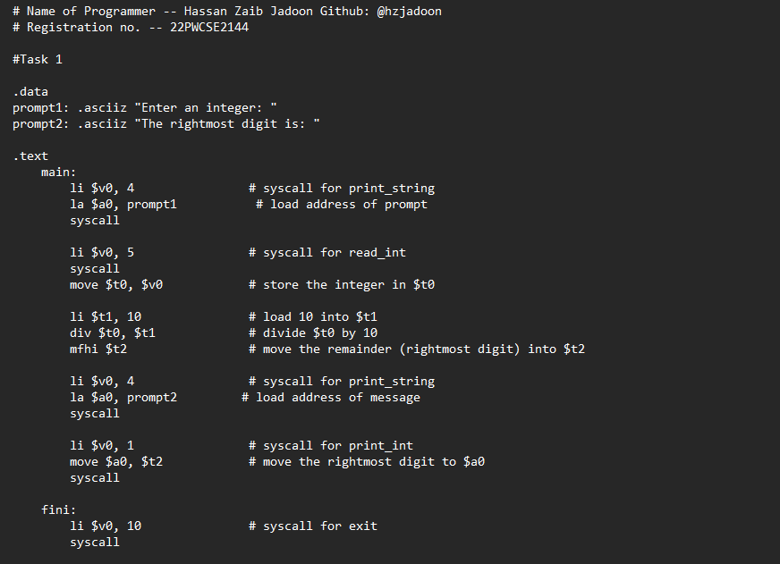

**Output:**

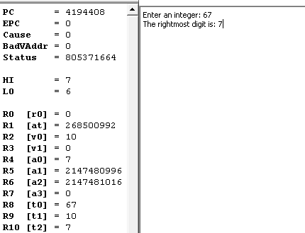

**Task 2:**

Modify `Lab5_1.asm` to print strings on separate lines using a newline character `\n`.

**Code:**

**Output:**

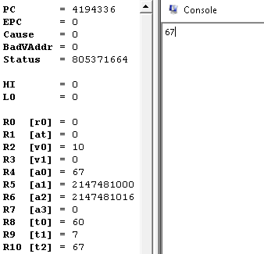

**Task 3:**

Investigate the difference between `.ascii` and `.asciiz` directives.

**Code:**

**Output:**

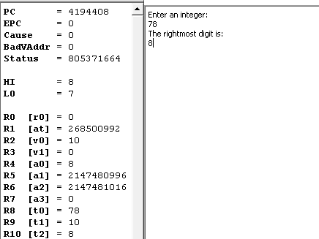

**Task 4:**

Write a function to calculate the length of a null-terminated string using the `jal` instruction.

**Code:**

**Output:**

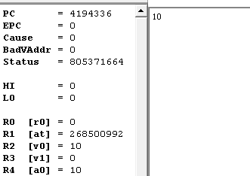

**Task 5:**

Modify the program to count elements in a null-terminated array of words.

**Code:**

**Output:**

